ALPHAX Compiler

Manual

Development by ALPHAX

National Autonomus University of Mexico

Faculty of Engineering

“Compilers”

Ing. Norberto Jesús Ortigoza Márques

Developers:

* Flores Constantino Diego
* Rojas Castañeda Karen Arleth

Index

**Objective** 2

**Introduction** 2

**Members** 2

**User manual** 2

Installation prerequisites 2

Installation 2

Execution 3

Test 3

# **Objective**

The purpose of this document is to show the user how the Algol compiler works.

# **Introduction**

The following written represents a manual for the use of the Algol Compiler. We show the installation requirements, the steps to follow for the installation, and the commands required to run and test the Algol Compiler.

# **Members**

* Flores Constantino Diego.
* Rojas Castañeda Karen Arleth.

# **User manual**

## Installation prerequisites

1. You need to have a current version of elixir (1.11.2) on your computer

If you don’t have it, you can download it here.

1. The complete project is in a Github repository, so, to download it you need to have an account. <https://github.com/>
2. Have Git installed.

You can download it at the following link. <https://git-scm.com/downloads>

1. Have a window operating system.

## Installation

The complete compiler program can be found on page <https://github.com/rojaspixel07/Alphax.git> . Once inside the page, it is necessary to click the download button and copy the URL that appears within the following box.

The next step is to clone the repository in some folder on our computer, in this case, we did it on the desktop and for this, and the following command is typed in the terminal:

* git clone <https://github.com/rojaspixel07/Alphax.git>

The next step is to change to the **Alphax** folder by typing:

* $ cd **alphax**

The folder where the execution and subsequent tests can be done is **alphax_compiler**

With $ls we can look for it.

We are in it typing:

* $ cd **alphax_compiler**

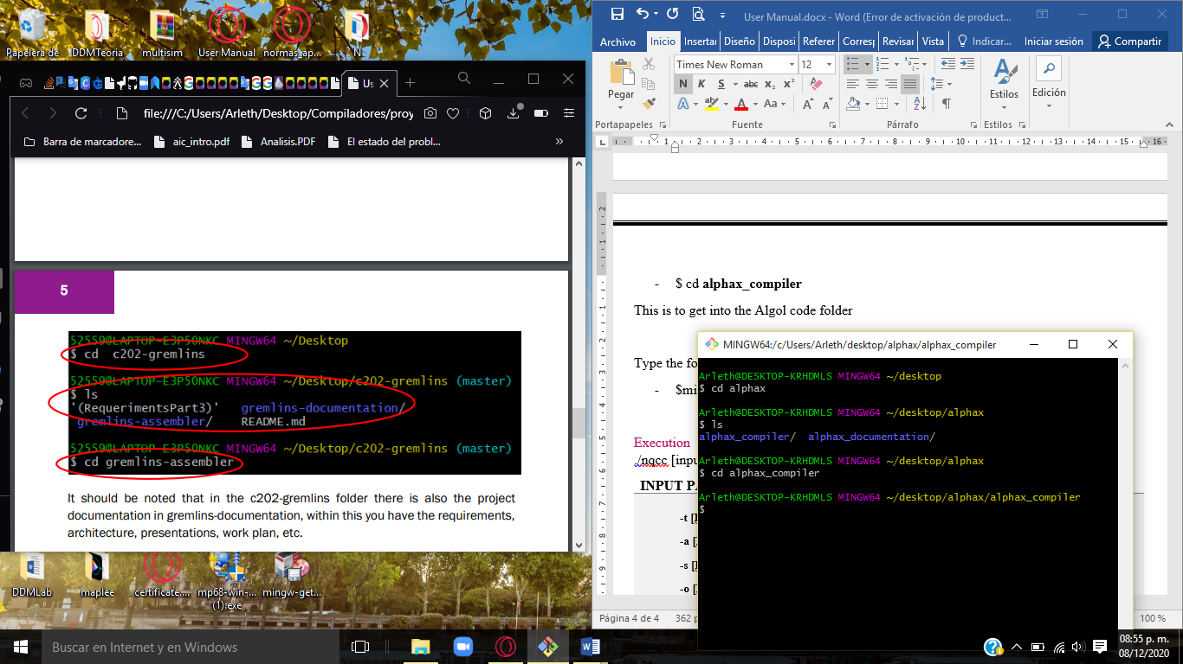

This is to get into the Alpha code folder

Type the following command to generate an executable:

* **$mix escript.build**

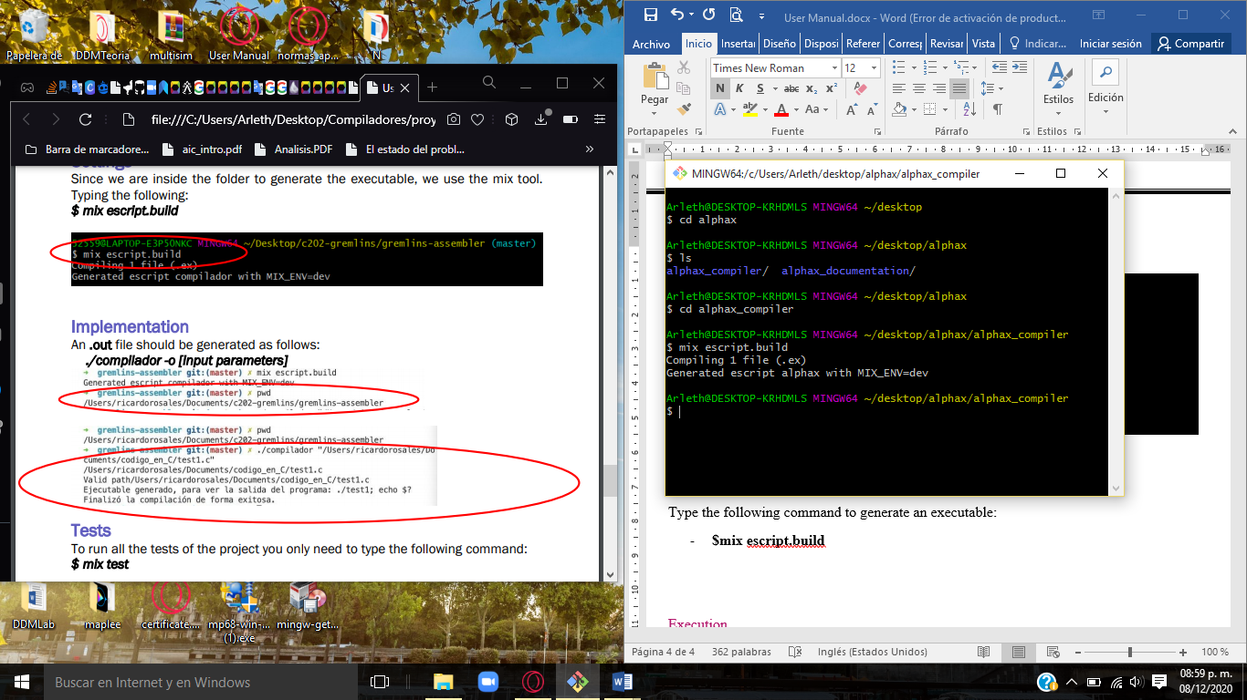

## Execution

**./Alphax <input parameters>**

|  |  |
| --- | --- |
| Input Parameters |  |
| **-c <File_name.c>**  **-t <File_name.c>**  **-a <File_name.c>**  **-s <File_name.c>**  **-o <File_name.c>** | Compile program (check the same folder for [file name].exe).  Show token list  Show AST  Show assembler code  [newName] | Compile the program with a new name. |

## Test

To run all the tests of the project you only need to type the following command:

* **$ mix test**

